1.Install Nox:

2.On debugger mode

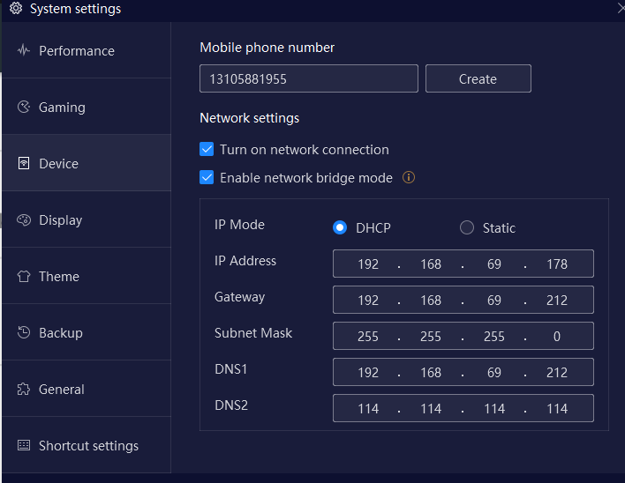3. Enable Bridge Mode and restart

On your vm in Bridge mode and install abd

Run following command to connect nox

root㉿kali)-[~/Desktop]

└─# adb connect 192.168.69.178:5555

connected to 192.168.69.178:5555

┌──(root㉿kali)-[~/Desktop]

└─# adb devices

List of devices attached

192.168.69.178:5555 device

To take shell of device:

#adb shell

To check a specific package:-

root㉿kali)-[~/ludo]

└─# adb shell pm list packages | grep uber

package:com.ubercab

To check path of package:-

(root㉿kali)-[~/ludo]

└─# adb shell pm path com.ubercab

**package:/data/app/com.ubercab-2/base.apk**

package:/data/app/com.ubercab-2/split_VoipTwilio.apk

package:/data/app/com.ubercab-2/split_VoipTwilio.config.armeabi_v7a.apk

package:/data/app/com.ubercab-2/split_VoipTwilio.config.xhdpi.apk

package:/data/app/com.ubercab-2/split_config.armeabi_v7a.apk

package:/data/app/com.ubercab-2/split_config.en.apk

package:/data/app/com.ubercab-2/split_config.hi.apk

package:/data/app/com.ubercab-2/split_config.xhdpi.apk

To pull base.apk in you current directory----

─(root㉿kali)-[~/ludo]

└─# adb pull /data/app/com.ubercab-2/base.apk

/data/app/com.ubercab-2/base.apk: 1 f... 32.4 MB/s (83253863 bytes in 2.449s)

To uninstall application:

(root㉿kali)-[~/ludo]

└─# adb uninstall com.ubercab

Success

To reinstall again you should pull all pckgs of application in your current directory. Then run

(root㉿kali)-[~/ludo]

└─# adb install base.apk

Performing Streamed Install

Success